**Ideation Phase**

**Define the Problem Statements**

|  |  |
| --- | --- |
| Date | 25 June 2025 |
| Team ID | LTVIP2025TMID35341 |
| Project Name | Smart Sorting: Transfer Learning for Identifying Rotten Fruits and Vegetables |
| Maximum Marks | 2 Marks |

**Customer Problem Statement Template:**

Create a problem statement to understand your customer's point of view. The Customer Problem Statement template helps you focus on what matters to create experiences people will love.

A well-articulated customer problem statement allows you and your team to find the ideal solution for the challenges your customers face. Throughout the process, you’ll also be able to empathize with your customers, which helps you better understand how they perceive your product or service.

Reference: <https://miro.com/templates/customer-problem-statement/>

**Example:**

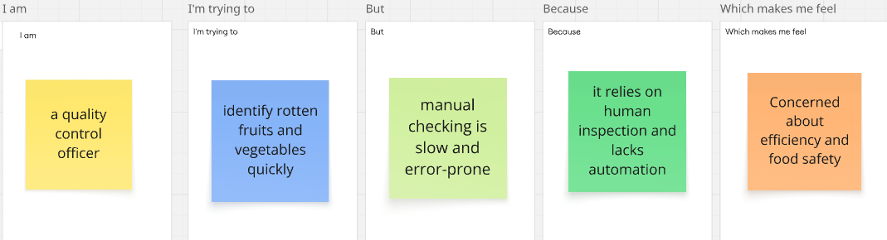

|  |  |  |  |  |  |
| --- | --- | --- | --- | --- | --- |
| **Problem Statement (PS)** | **I am (Customer)** | **I’m trying to** | **But** | **Because** | **Which makes me feel** |
| PS-1 | Food Processing Plant Manager / Supermarket Quality Control Manager | Efficiently and accurately sort large volumes of fruits and vegetables to identify rotten ones before distribution or sale. | Food Processing Plant Manager / Supermarket Quality Control Manager | It involves visually inspecting thousands of items, leading to human fatigue, inconsistencies in quality assessment, and significant operational costs. | Frustrated with inefficiencies, concerned about product quality consistency, and worried about increased operational costs and food waste from undetected spoilage. |
| PS-2 | Home Consumer / Household Member | Keep track of the freshness of my fruits and vegetables at home and reduce food waste. | I often forget about produce until it's rotten, or I'm unsure if an item is still good to eat without cutting into it. | There is currently no easy and reliable way to automatically monitor the spoilage of individual produce items in my refrigerator, leading to frequent food spoilage and unnecessary waste. | Frustrated and worried about patient outcomes and operational efficiency |